|  |
| --- |
| **National University of Computer and Emerging Sciences** |
| Lab Manual  “Introduction to Data Warehousing” |
|  |
| Data Warehousing and Data Mining |
|  |
|  |
|  |

|  |  |
| --- | --- |
| Course Instructor | Ishaq Raza |
| Lab Instructor(s) | Uzair Naqvi  Ahsan |
| Section | A |
| Semester | Fall 2016 |

|  |
| --- |
|  |

Department of Computer Science

FAST-NU, Lahore, Pakistan

Table of Contents

[1. Task Distribution 3](#_Toc308789883)

[2. Objective 4](#_Toc308789884)

[3. Required material 4](#_Toc308789885)

[4. Pivot charts/tables MS Excel 5](#_Toc308789886)

[5. Creating table in MS SQL Server 6](#_Toc308789889)

[6. Import data into table 12](#_Toc308789894)

[7. Selecting Data 14](#_Toc308789897)

[8. Exercise 1 15](#_Toc308789900)

[9. Exercise 2 16](#_Toc308789901)

[A - SQL 17](#_Toc308789902)

## Task Distribution

*Total (170 minutes)*

* + **Introduction to Data Warehousing** *(20 minutes)*
  + **Business intelligence and decisions making using Microsoft Excel** (30 minutes)
  + **SQL Server 2012 Installation & Configuration** *(10 minutes)*
  + **Microsoft SQL Server 2012 Review**  (35 minutes)
  + **Practice Exercise** *(75 minutes)*

## Objective

The purpose of this lab activity is to make you familiar with data warehousing environment. We will take sample data and look into Microsoft Excel and see how business intelligence can be achieved in Microsoft Excel. At the end of this lab you will be able to perceive a bit of why we need a data warehouse and whatit is. A data warehouse is a [repository](http://en.wikipedia.org/wiki/Information_repository) (collection of resources that can be accessed to retrieve information) of an organization's electronically stored data, designed to facilitate reporting and analysis.

We will also review and revise SQL server 2012 concepts that were previously covered in database systems course.

At the end of this lab you will be able to

* + Setup SQL server environment
  + Table creation, definition through script & Design view.
  + Creating Basic reports and decision making using Excel pivot charts and pivot table.
  + Data import and export from files to DBMS (tables) using SQL import export utility.
  + Creation of Views and Simple SQL queries.

## Required material

* Script files [**scripts.zip**](file:///I:\Data%20Warehousing%20Lab%202015\Labs\Lab%201%20(SQL%20Over%20View)\scripts.zip)
* SQL server installation guide [SQL server 2012 installation guide.pptx](file:///I:\Data%20Warehousing%20Lab%202015\Labs\Lab%201%20(SQL%20Over%20View)\SQL%20server%202008%20installation%20guide.pptx)

## Pivot charts/tables MS Excel

Pivot chart or a Pivot table is a special data analysis tool that allows you to summarize and explore data interactively.

|  |  |
| --- | --- |
| Task 1: Selecting data from the table using selection Query | **Estimated completion time (min):** 30 |
| Step 1:  1. Start->Program Files ->Microsoft office -> Excel 2007 2. Open the pivot charts data excel file given to you. 3. Select the entire data. 4. Select Insert-> and then select pivot charts. 5. Select your location, Axis and Legendand then draw your chart. 6. Row labels are called axis fields and column labels are called legend fields. | |

## Creating table

|  |  |
| --- | --- |
| Task 1: Creating table using SQL server management studio designer | **Estimated completion time (min):** 10 |
| Step 1: Open SQL server management studio  1. Start->Program Files ->SQL server 2012 -> SQL server management studio 2. Enter your server name as username password   C:\Users\uashraf\Desktop\sivasqlbi_Sivakumar_Vellingiri_33.jpg   1. Add new Database     **Step 2: Creating Table through designer**   1. Add new table     2.Define column field    3. Save table and Give it meaningful name to save. | |
| Task 2: Creating table through script (DDL and DML) | **Estimated completion time (min):** 10 |
| Steps:  1. Open query window by clicking new query      1. Select your database      1. Copy the script given in the script file (Refer to Requirement Section) and paste it into your query window. Also change the first line where use [lab2] is written. Change lab2 to your database name.      1. Click Execute to run your query and your table will be created with the message of “command executed successfully” | |

## Import data into table

|  |  |
| --- | --- |
| Task 1: Import data in to tables using Import Export utility | **Estimated completion time (min):** 10 |
| Step 1:  1. Start->Program Files ->SQL server 2012 -> Import and Export data 2. Select your source (source files are also given in script folder refer to Requirements Section).You have to repeat the following steps for all the tables you are going to create and source text files related to all tables are also given in the script file.      1. Don’t forget to check “Column names in the first data row” 2. Select your destination table.      1. Press finish button to start importing data from text file to your destination table. | |

## Selecting Data

|  |  |
| --- | --- |
| Task 1: Selecting data from the table using selection Query | **Estimated completion time (min):**5 |
| Step 1:  1. Start->Program Files ->SQL server 2012 -> Management studio 2. Select your database 3. Open Query window 4. Execute Query. | |

## Exercise 1

1. Get the Excel file from the Assignment folder (Question2.xls).

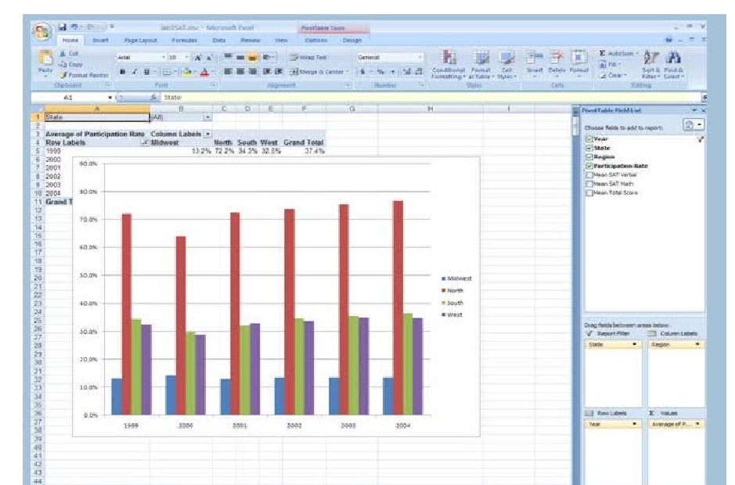2. Draw a pivot table and pivot chart as shown below:

## Exercise 2

A Relational Database is to be set up for you to query. The tables in the database are given:

|  |  |
| --- | --- |
| **Table Name** | **Attributes** |
| Department | DepartmentID,Name,GroupName,ModifiedDate,datetime |
| Employee | EmployeeID,NationalIDNumber,ContactID,ManagerID, Title,BirthDate,MaritalStatus,Gender |
| EmployeeAddress | EmployeeID,AddressID,AddressLine1,AddressLine2,City,StateProvinceID,PostalCode |
| EmployeeDepartmentHistory | EmployeeID,DepartmentID,ShiftID,StartDate,EndDate,ModifiedDate |
| EmployeePayHistory | EmployeeID,RateChangeDate,Rate,PayFrequency, ModifiedDate |
| Project | PrjectID,Name,StartDate,EndDate,DeptID |

## A - SQL

1. Get the marital status(listed once only) of all the male employees.
2. Get the Employee ID and National Id of all the employees having Rate more than 24.
3. Find the ID of employees working on project description Stock market.
4. Give the name of departmenton which employee 7 is working
5. Give the description of projects on which employee 3 never worked.
6. Give a count of each employee’s association with Department. An employee works with how many departments currently.

(Note: Currently means EndDate is not marked)

1. For all the unique values of DaysPerWeek field in EmployeePayHistory table, count the number of employees and Maximum Rate among the employees.

**Note:**

* + You are supposed to submit the SQL code and your database creation script or database.
  + Each query and procedure should be able to run on SQL server 2012.